**CSSE3101 – ADVANCED WEB TECHNOLOGIES**

**STUDENT CENTERED ACTIVITY 4 – React Basics (Components, Routers, Hooks and Lists)**

**Create a currency converter React application using the following conversion values:**

**Part 1 – Creating Components**

1. Create a new react app: **currencyconverter**
2. Create a folder **Components** and create the following components inside the created folder. Refer to the screenshots for the content for each component. Any apply necessary bootstrap classes.

**Home component**

In the Home component, design the following user interface featuring input elements for entering an amount and a selection for converting between Omani Rial (OMR) and US Dollar (USD). Depending on the chosen conversion option, the component should perform the currency conversion. Utilize essential Hook state variables to accomplish this task and apply Bootstrap classes to style the input controls.

Note: **1 OMR = 2.60 US Dollar, 1 US Dollar = 0.39 OMR**

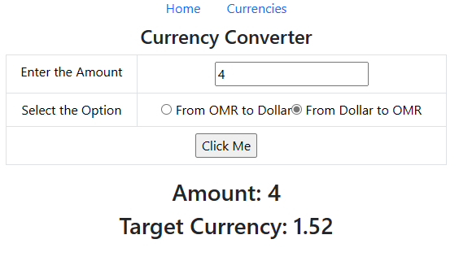

**Currencies** component – Using list and map method.

1. In the Currencies component:
   1. Create an array containing a minimum of five default currency values.

**['US Dollar', 'Yuan','Dirham','Rial','Rupees']**

* 1. Render these currencies as an unordered list when the component is initialized.
  2. Use the map method with an arrow function to display the elements of the array.

**Part 2 – Creating Routes**

1. Update your App.js and use the React Router to create routes and link for these two components.
   1. /-render the **Home** component.
   2. /currencies- render the **currencies** component.
   3. Apply the appropriate Bootstrap classes to **nav** tag and **Link** component.